**Programming Skill Examination.**

**Company**: Transcosmos Technologic Arts

**Period**: 12h (5/5/2015 1:00 PM and all day 6/5/2015)

1. **Summary**
   1. Alpha is an Online Mobile Shopping and they want to develop a website that allows user to buy the mobile phone online and cash on delivery (COD) only. Website allows user can add product to cart, checkout to see the payment at cart detail, input his/her address for COD and order product online.
   2. Because of special requirement for this shop so that the owner required user has to login before selecting and ordering the product.
   3. Alpha shop will send via email the Coupon ID frequently to the list of users who has ever ordered at Alpha shop.
      1. The coupon has 4 kinds of coupon type
         1. Coupon Type:
            1. Ruby will discount 10%
            2. Diamond will discount 18.5%
            3. Emerald will discount 25.5%
            4. Sapphire will discount 28%
         2. For each Coupon will valid from start date and expiration date and has the following status:
            1. Used: has already used by user
            2. Unused: has not used by user and not expired.
2. **Activity Diagram**

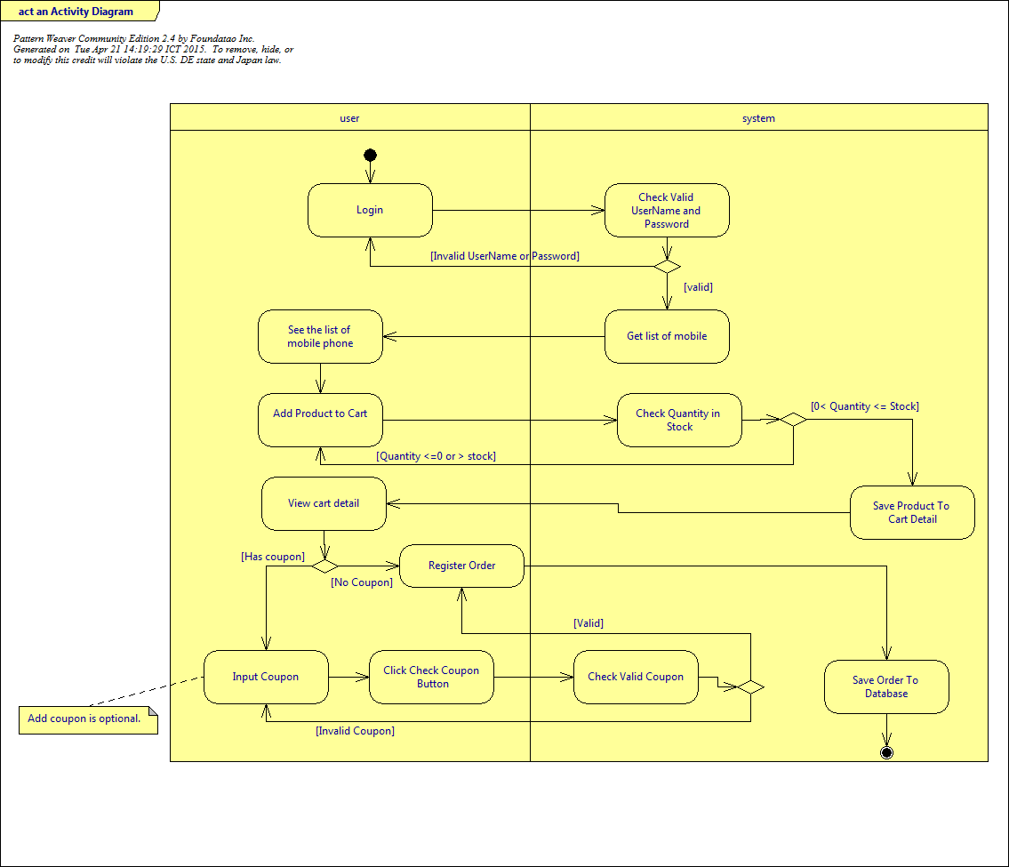

1. **Use case diagram**

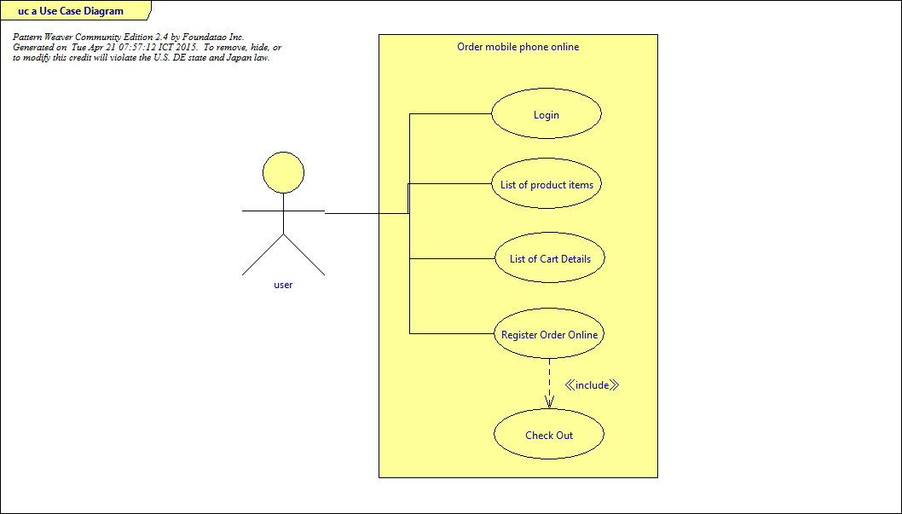

1. **Scenario**: Nguyen Van A wants to visit Online Mobile Shopping commerce site for shopping some products Online Mobile Shopping commerce site is site to sell products, Payment method: CoD (Cash on Delivery)
   1. **Scenario Overview**:
   2. **Precondition**:
      1. Nguyen Van A has to login to the **E-commerce** site (with username/password).
      2. Already have some users in database.
      3. List of mobile phone products exist in database
   3. **Step**:
      1. **Step1**: List all products
      2. **Step2**: Want to add product to shopping cart from list
         1. The Iphone 6 plus 16GB has price 20.000.000 VND and he want to buy 2, Enter quantity 2
         2. Press Add to Cart, The system will check quantity.
            1. If in the store have less than 2: Information message “The number of IPhone 6 plus 16 Gb is not enough to sell.”
            2. If in the store has greater or equal to 2 then redirect to (Step 4) Cart detail page with adding 2 IPhone 6 Plus.
      3. **Step3**: Click Continue shopping button at Cart detail **if** he want to buy other Product (1 IPhone 6 Plus 128DB price 26.000.000 VND), return Step 2
      4. **Step4:** Checkout Cart
         1. Click on Checkout button at List Product page.
         2. List products of user Nguyen Van A added to Cart Detail with:

Product detail: Product name, price, quantity, amount as below

|  |  |  |  |
| --- | --- | --- | --- |
| Product Name | Price | Quantity | Price |
| Iphone 6 Plus 16 GB | 20.000.000 | 2 | 40.000.000 |
| Iphone 6 Plus 128 GB | 26.000.000 | 1 | 26.000.000 |
|  |  | Total of Order | 66.000.000 |

* + - 1. **Note**: When User logs out and logs in again, the history of cart detail will be empty.
    1. **Step5**: View summary of Order and input Coupon Code (If has) and input Address information:
       1. Nguyen Van A has 3 Coupon Code
          1. AAAAAA (sale of 10%) : has used in previous shopping
          2. BBBBBB (sale of 14%): has expired yesterday
          3. CCCCCC (sale of 20%) : has not used and will be expired in next month
       2. Nguyen Van A enter coupon code:
          1. With AAAAAA: the system will expose message "Coupon has already used".
          2. With BBBBBB: the system will expose message "Coupon has expired".
          3. With CCCCCC**1**: the system will expose message “Coupon does not exist.”
          4. With CCCCCC: the system will re-calculate Order.
       3. The total of Other with CCCCCC coupon will be (66.000.000 – (66.000.000 *20%) = 52.800.000 VND.
       4. Require to input the address of user.
       5. Click on “Register Order” button.
    2. **Step 6: Complete Order**
       1. Order saves to the system.

After user clicks on “Register Order”, the information will save to tbl_order and tbl_order details.

* + - 1. Quantity of **Products in store will reduce with number as in Order.**
      2. Notify message “**Your order Id is 1 has been received and is currently in verification process.”**
      3. **Clean the session, product items in cart detail.**

1. **Database structure**.
   1. **tbl_user**

|  |  |  |  |  |
| --- | --- | --- | --- | --- |
| Id | Primary key | int(11) | Not null | User id |
| user_name |  | varchar(50) | Not null | User Name |
| password | SHA-2 | |  | | --- | | varchar(64) | | Not null | Password |
| first_name |  | |  |  | | --- | --- | |  | varchar(50) | | Not null | Last name |
| last_name |  | |  | | --- | | varchar(50) | | Not null | First Name |
| isactive |  | |  | | --- | | boolean | | Default False | False: cannot login to the system |
|  |  |  |  |  |

* 1. **tbl_coupon_type**

|  |  |  |  |  |
| --- | --- | --- | --- | --- |
| Id | Primary key | int(11) | Not null | Coupon type id |
| name | unique | varchar(50) | Not null | Coupon type name |
| discount |  | float | Not null | Number of percentage. |

* 1. **tbl_coupon**

|  |  |  |  |  |
| --- | --- | --- | --- | --- |
| Id | Primary key | int(11) | Not null | Salary id |
| coupon_type_id | Foreign Key | int(11) | Not null | Coupon Type id |
| name |  | varchar(50) | Not null | Coupon Name |
| code |  | varchar(13) |  | Coupon code |
| start_date |  | datetime | Not null | Start date of coupon |
| expired_date |  | datetime | Not null | Expire date of coupon |
| status |  | boolean | 0: inused  1: used | Status of coupon has used or not. |

* 1. **tbl_product**

|  |  |  |  |  |
| --- | --- | --- | --- | --- |
| Id | Primary key | int(11) | Not null | Product id |
| name |  | varchar(100) | Not null | Product Name |
| code |  | varchar(13) | Not null | Product Code |
| stock_quantity |  | int(11) | Not null | Quantity of product |
| sale_price |  | double(12,0) | Not null | Price of product |
| last_update |  | datetime | DEFAULT CURRENT_TIMESTAMP | Last update product |

* 1. **tbl_order**

When user click “Register Order” all information will be saved to this table.

|  |  |  |  |  |
| --- | --- | --- | --- | --- |
| Id | Primary key | int(11) | Not null | Order id |
| user_id |  | int(11) | Not null | User ID |
| coupon_id |  | int(11) | Default null | Coupon Id |
| discount |  | float | Default null | Percent of coupon get from coupon_type table. |
| address_info |  | text |  | Last update product |
| total_payment |  | double(12,0) | Not null | Total of payment after reduce the discount if exist. |

**Total_Payment is the total payment (summary from order detail) after reduce the discount if exist.**

**OrderDetail_Payment = OrderDetail[(quantity1 * sale_price2) + (quantity2 * sale_price2) + …]**

**Total_Payment = OrderDetail_Payment – (OrderDetail_Payment%discount)**

* 1. **tbl_orderdetail**

When user click “Register Order” all information will be saved all products to this table

|  |  |  |  |  |
| --- | --- | --- | --- | --- |
| id | Primary key | int(11) | Not null | Order Detail id |
| quantity |  | int(11) | Not null | Quantity of product |
| order_id | Foreign key | int(11) | Not null | Order Id |
| product_id |  | Int(11) | Not null | Product id |
| creation_date |  | datetime | DEFAULT CURRENT_TIMESTAMP | Date time of creation order. |

1. **Requirement.**
   1. Please implement a web application:
      1. Allow user login in by user name and password(SHA-2)
         1. If the user is not active, he/she does not allow to login.
         2. When user login to the system, the password has to encrypt by SHA-2 before check it in user table.
         3. In the SHA-2, the default digest algorithm uses is SHA-256.
      2. Validation all the required field.
      3. Check validation of quantity when adding product to cart
      4. Check validation of coupon: used, inused, expired, not exist,
      5. This web application should work well on IE and Firefox browser.
      6. Write Todo List and Unit Test for this program.
      7. You can apply a framework you are familiar.
      8. Make sure you develop good code quality, test coverage and Security.
      9. Write steps how to set up and run your project in order to Group Leader to check
      10. Write Integration Test is plus if you have time.
   2. Note
      1. Please refer to the html file from index.html->listproduct.html-> cartdetail.html
         1. For mobile team, the UI will be the same and logic, but you have to implement it on mobile application.
         2. **Mobile application's requirement about local data's security:**

You need to use an algorithm to encrypt the **address_info** field of tbl_order table in local data which you will save with a key = **"KEY_TTV_12345678"**

* 1. **Requirement Support structure**
     1. **Programming Skill Examination 2.docx, .doc, it is the same content**
     2. **php_java**
        1. db
           1. order.sql

user login: hieu/hieu or hung/hung

You can use sha2(‘hieu’,256) function to test Sha2 in database;

Password was encrypted by SHA-2

* + - * 1. connect.php
      1. html
         1. index.html
         2. listproduct.html
         3. cartdetail.html
    1. **mobile**
  1. **Source code release and project name**
     1. Create a project with your name:
        1. Example: VO_VAN_KY
     2. Create db folder and export your local db to script.sql and put it in your project folder
        1. Example: VO_VAN_KY/db/order.sql
     3. When you finish your project, push your project to http://10.190.201.76/ky/examinationq2
        1. Example: source_code/VO_VAN_KY
        2. If some engineers are not familiar on git, we can help you.